

Cellfind Messaging Portal is a user-friendly
web interface for instant, two-way
communication with individuals or groups
via single or bulk SMS and WAP push messaging.



This document contains information, which is the property of
CELLFIND (Pty) Ltd.
No part of this document may be reproduced, transmitted or divulged to third parties in any form or by any means, without written permission from CELLFIND (Pty) Ltd.

Document Status | draft
Version: | 2.1
Filename: | Cellfind Messaging Portal User Guide
Last Revision Date: | Monday, 6 October 2014
Reviewer(s) | - Brent Wantenaar

- The aim of this manual is to provide the delegate:
An explanation of basic concepts.
A guide for using the products Tex-t offered by Cellfind (Pty) Ltd
Provide assistance in the creation of a Comma Separated value (CSV) file.
Provide cost effective communication & messaging solution

- The user will be able to:
Explain basic concepts
Create and use a CSV file to add contacts
Use the products Tex-t efficiently

- Introduction

  - Use the Cellfind products to adopt and ensure cost effective communication needs

Cellfind provides highly flexible communication solutions that are indispensable to your operational needs. These solutions can be applied to many aspects of your communication processes helping you to communicate better, faster, and more reliably.

  - Why and How?

Tex-t and the premium rated short codes will ensure that you:
• Improve speed and effect.
- Reaching the right people with critical information when they need it can mean the difference between success and failure. One person, with the touch of a button can send clear, targeted communications to any number of people anywhere, anytime, and on any device
- Schools could send out exam dates to all the learners’ parents/guardians.
• Enable staff to meet increased work demands.
- Financial institutions could keep their clients updated.
• Cost effective and Critical information dissemination
- Large-scale communication tasks increase operational costs as they place greater demands on the resources needed to perform these tasks. Cellfind offers an in-house system that does not require a large investment with regard to equipment, software, or support costs. The benefits to your organisation are limitless.
- These products increase customer interaction, hence increasing and developing customer relations.
- Get feedback from clients on products, needs, etc.
- Inform the entire staff, clients of changes in product range etc.
  - • Track critical communications.
  - These solutions will also allow users with feedback, as to the tracking and delivery of critical information.
  - Through the reports functionality delivery reports can be run.

1 Cellfind Messaging Portal 4
1.1 Tex-T Pro 4
2 Logon 5
3 Profile 6
3.1 Address Book 7
3.2 To add a Contact 8
3.3 Add contact Group 9
3.4 Upload Contact CSV 9
4 Message tab 11
4.1.1 Scheduled Messages 12
4.1.2 Send SMS 12
4.1.3 Send SMS (Bulk) 13
4.1.4 Send MMS 15
4.1.5 HLR 18
4.1.6 Send WAP 20
Send WAP (Bulk) 21
4.1.7 Sent Items 23
4.1.8 Remove Replies 25
4.1.9 View Replies 25
4.1.10 View Bulk Files 26
5 Premium Rated 27
5.1 Auto Replies 28
5.2 Auto Replies (Shared) 31
5.3 Inbox 31
5.4 Inbox (Export) 32
5.5 Inbox Ref 32
5.6 Last Message 33
5.7 Remove Messages 34
5.8 Unique Originator Count 34
5.9 Short Code List 35
6 Reports 35
6.1 Standard Reports 35
6.1.1 Incoming msg count by date and short code 35
6.1.2 Incoming msg count by date and short code and account 37
6.1.3 Outgoing msg count by date and user 37
6.1.4 Outgoing msg count by date, user and account 37
6.1.5 Scheduled msg by date and user 38
6.2 Detailed reports 38
7 Log Out 39
8 Contact details 39

Cellfind Messaging Portal

Tex-T Pro

This simple to use web interface will allow customers to communicate instantly with individuals or groups of people via single / bulk SMS & WAP push messaging. Cellfind will provide two-way messaging allowing customers to receive SMS replies to an inbox. Send and receive SMS messages without the need of a cell phone, Cellfind’s Text-T pro is a mobile office accessible to any web enabled PC.
Manage all your communication without having to spend money on expensive infrastructure.
Premium Rated Short Code Services
Cellfind is a registered WASP that can provide you with a 5-digit Short Code where users can SMS to and pay premium rates from standard rate costs up to R30 per SMS.
We will provide you with access to a website with which you can access all your inbound SMS’s, run reports, manage your short codes and set up auto replies.
All of this is based on a revenue share between the originating network, Cellfind as the WASP and you, the host of the number.
Premium Rated SMS number like 3xxxx/4xxxx can be used to effectively advertise services, products or competitions.
The SMS revenue share depends on the price band and the network

HLR Lookup

HLR Lookup will afford customers with the ability to clean up their databases by checking if a sim card is active and whether the MSISDN is still on the original network.

API/Web Service Integration (allowing customers to integrate seamlessly into their backend system)
With Cellfind’s API, integration into all backend systems is easy and seamless. For automated reports and enhanced communication with your customer’s communication via SMS, MMS, USSD, WAP MSISDN forwarding is possible with Cellfind as your aggregator.

Outlook 2007 & 2010 Integration
Cellfind’s Messaging Portal also caters for integration into one of the worlds’ most popular corporate e-mail environments, Microsoft Outlook 2007. Communicate directly from your desk worldwide, send and receive SMS messages. Cellfind’s Messaging Portal offers an efficient and familiar platform to communicate to customers and staff while offering the ability to increase communication effectiveness and reduce cost.

Email to SMS service

Email to SMS is ideally suited to customers who have the need to submit bulk messages to Cellfind using email as the delivery mechanism. Simply email the bulk file to Cellfind and let our systems do the rest.

Logon
To sign up via the internet to Cellfind’s Messaging Portal go to the following
URL https://www.cellfindportal.co.za/gw/RegisterNewAccount.aspx
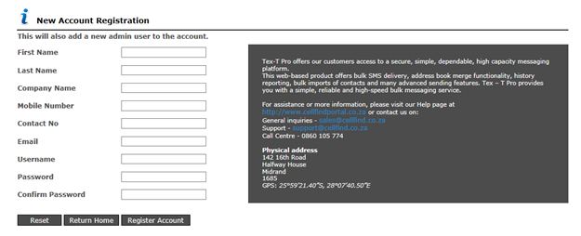

Customers who sign up via our dedicated Sales channel will receive there Usernames and Password via an email.
To access the Messaging portal go to the following URL https://www.cellfindportal.co.za/gw/Default

Submit your Login credentials in the space provided.
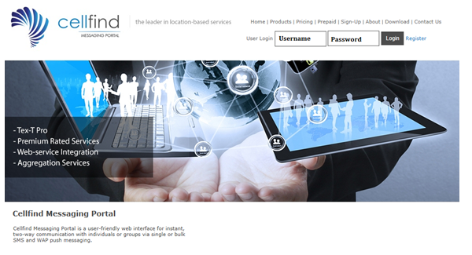

You will now see the following screen

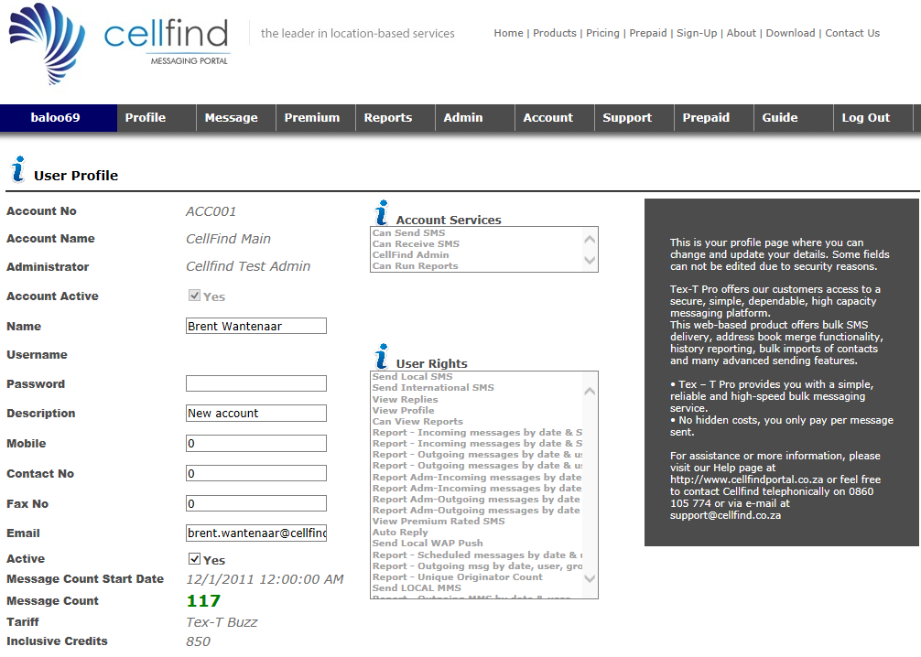

The following tabs will now be available for use:

Profile

To view or edit your profile details

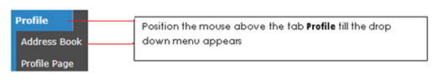

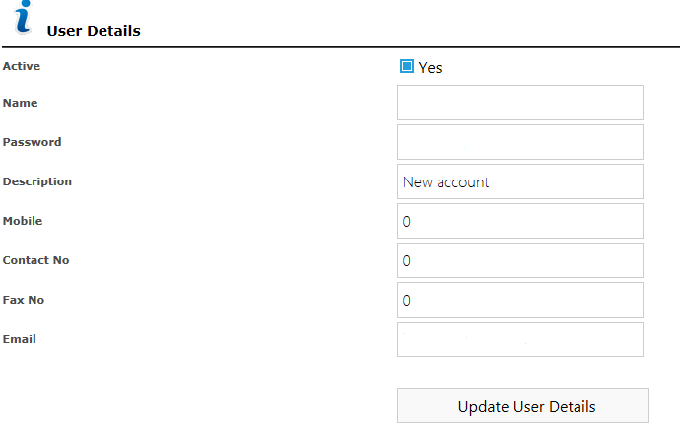

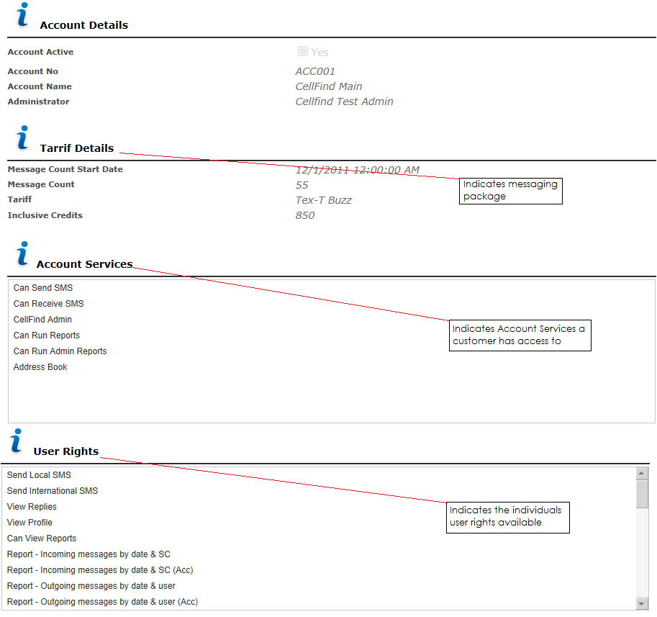

Address Book
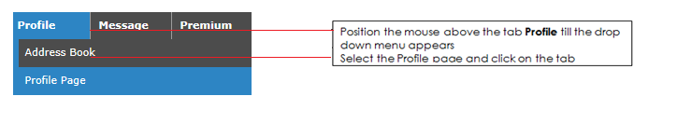

To add a Contact

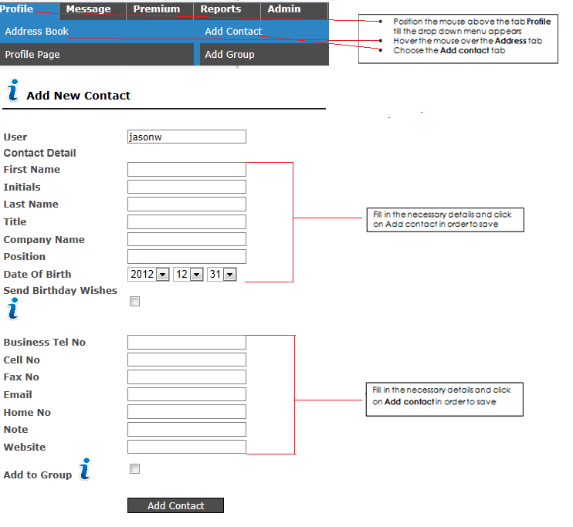

Add contact Group
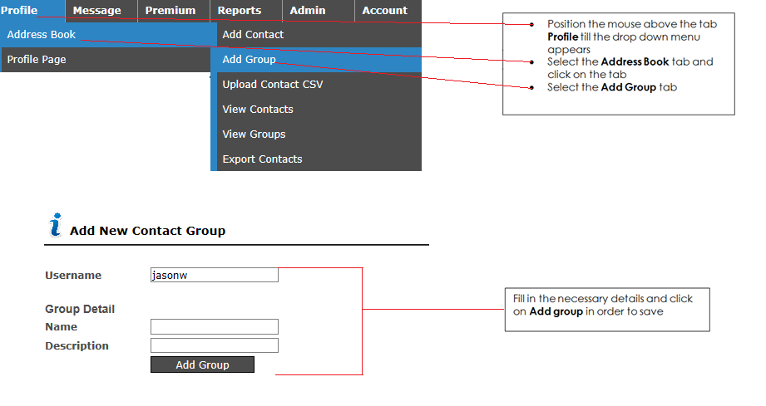

Upload Contact CSV
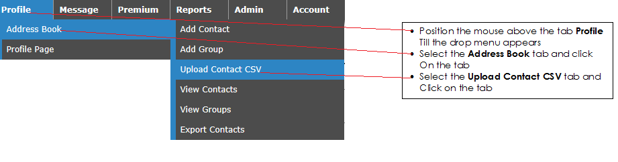Cellfind has enabled bulk contacts upload via a CSV file

This upload is not to be confused with the bulk sending capabilities please refer to page 14 in to set up a bulk SMS file
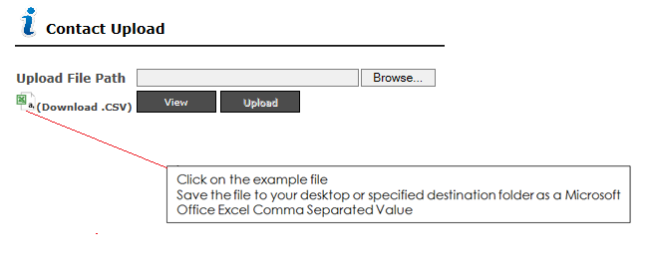

Or

Create a Comma Separated Value file (CSV file) using Excel.

If you already have a CSV file saved than this step can be skipped.
Using Microsoft Excel to edit the CSV example file and create your own contact list. (See below)

Creating a CSV file using Microsoft Excel

- Launch Microsoft Excel (Start > Programs > Microsoft Excel).
- In cell "A2", enter the first name of the first contact you want to create.
- Select cell "B2" by pressing the TAB key and type the Last name (Surname) of the contact.
- Select cell "C2" by pressing the TAB key and enter the contact's Mobile number.
- Select cell "D2" by pressing the TAB key and enter the group name, which the contact must be added to. If you do not want to specify a group, leave this column blank.
- Select cell "E2" by pressing the TAB key and enter the Initials for the contact. If you do not want to specify an initial leave this column blank.
- Right click on the column heading "F2" and enter the contacts title. If you do not want to specify a title leave this column blank.
- Select cell "G2" by pressing the TAB key and enter the Company name for the contact. If you do not want to specify a Company Name leave this column blank.
- Select cell "H2" and enter the contact's position in the company. If you do not want to specify a business telephone number, leave this column blank.
- Select cell "I2" and enter the contact's Date of Birth. If you do not want to specify a date of birth, leave this column blank.
- Select cell "J2" and enter the contact's business telephone number. If you do not want to specify a business telephone number, leave this column blank.
- Select cell "K2" and enter the contact's Fax telephone number. If you do not want to specify a Faxelephone number, leave this column blank.
- Select cell "L2" and enter the contact's email address. If you do not want to specify an email address, leave this column blank.
- Select cell "M2" and enter the contact's home phone number. If you do not want to specify a home phone number, leave this column blank.
- Select cell "N2" and enter any notes or reminders for the contact
- Select cell "O2" and enter any the contacts company website address
- Repeat steps 2-16 for each contact you want to add to the file.

Please note that the order of the columns (as shown in the example) should not be changed.
Your completed spread sheet should look like the one displayed as below.
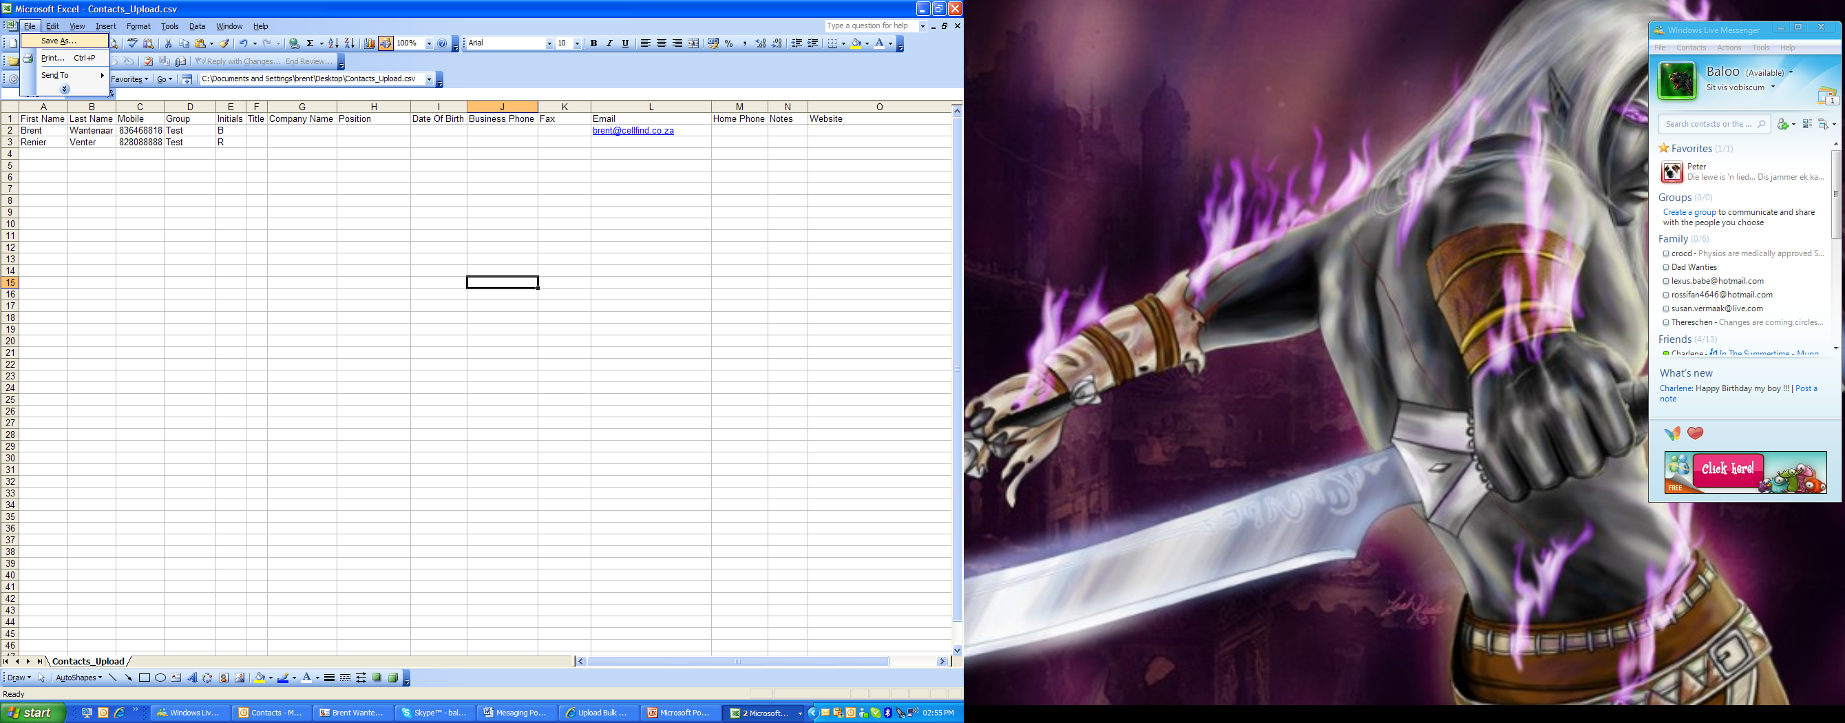

Once the list has been completed save the spreadsheet as a CSV file by following the next set of instructions.

- Once the list has been completed save the spread sheet as a CSV file by following the next set of instructions.
- Click on the “File” menu and select “Save As”
- Locate the destination folder to which you want to save the cont
- Give the file a name by entering a name in the "File Name" text box.
- Drop the "Save as Type" list down and select the "CSV(Comma Delimited)” option
- Click on the "Save" button to save the File.

Upload Bulk CSV contact File

- Click on Browse
- Choose the destination folder where the CSV contact file is saved
- Choose the file
- Click on view
- Click on upload

View Contact and/or groups

Message tab
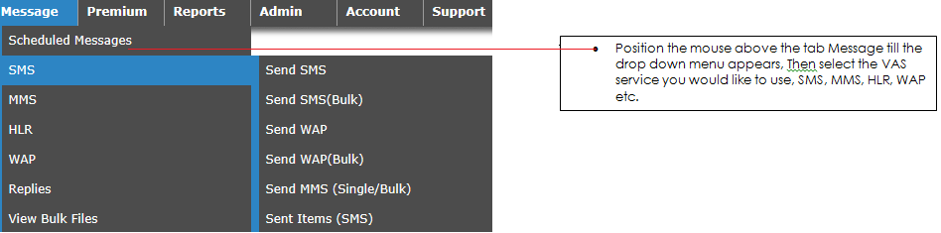

Scheduled Messages
This provides you with the list of messages you scheduled for delivery at a later date.
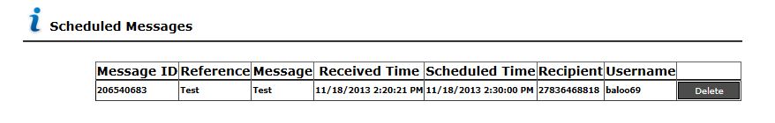

Message ID – refers to the unique ID tag Cellfind attaché’s to each message
Reference – refers to the reference you attach to the bulk file for the campaign
Message - Refers to the message you submitted for delivery
Received time – Refers to the time and date Cellfind received the bulk file
Scheduled time – Refers to the time that the bulk file is scheduled for delivery
Recipient – Refers to the cell number of the recipient who will receive the message
Username – Refers to the username of the user who has submitted the message

Send SMS
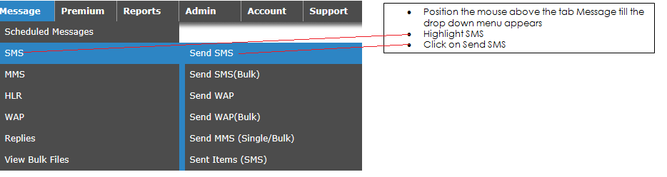
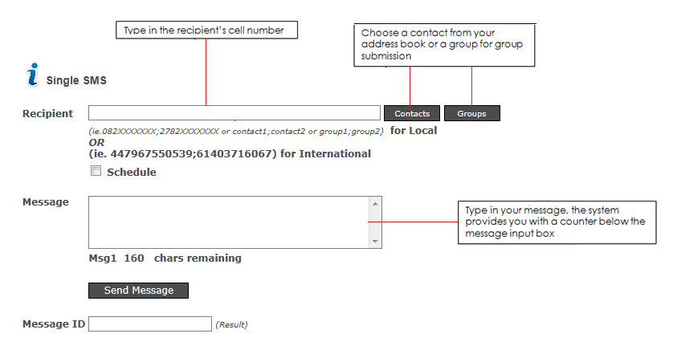
To submit more than one message separates the numbers with. ; i.e. 082XXXXXXX; 083XXXXXXX; 084XXXXXXX

Send SMS (Bulk)
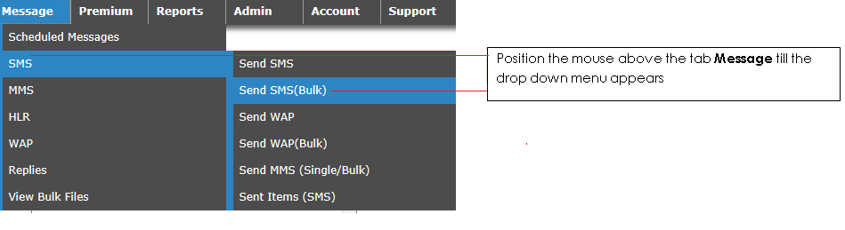

This function allows you to send multiple SMS’s at once by using a CSV file. These messages can also be scheduled for a future date.

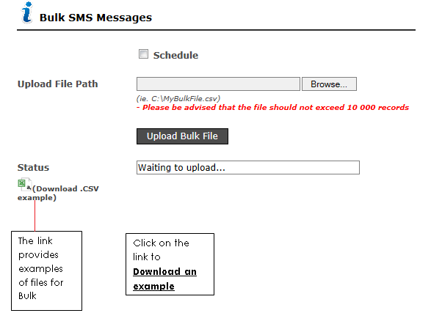

The following figures will show you how to set up a bulk file
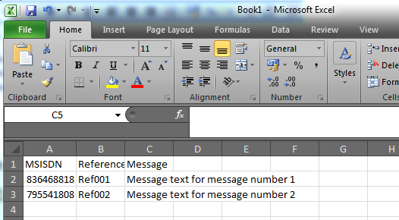

Once you have created the file and saved it to a folder on your PC as a
CSV file you will click on BROWSE

The following screen appears

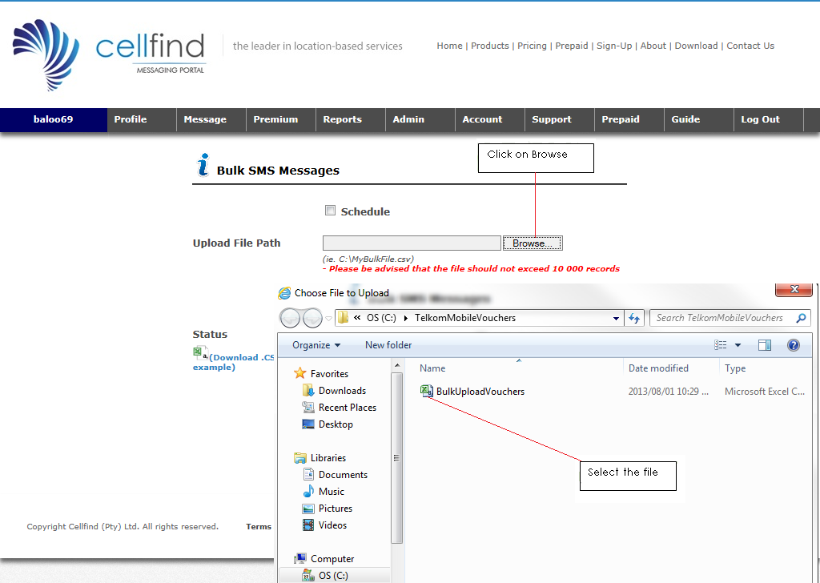
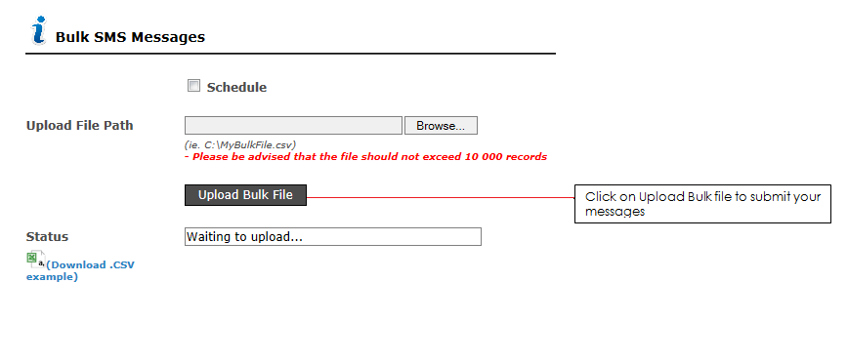

Once the message has been successfully uploaded the following screen will appear

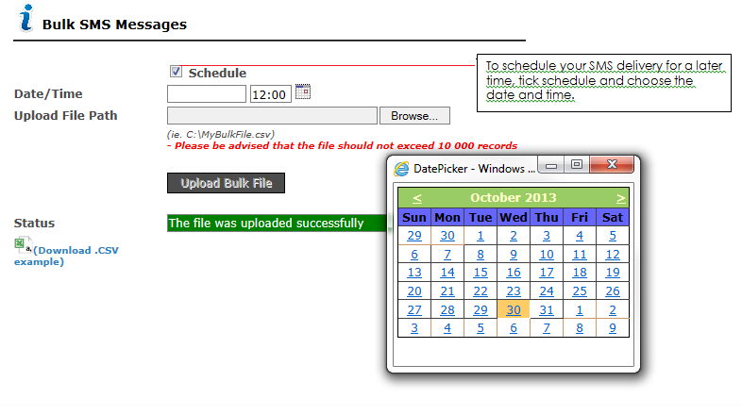

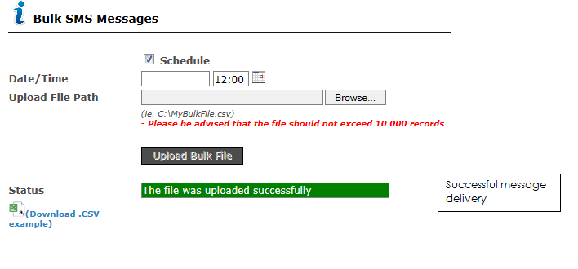

Send MMS

To send an SMS highlight the Message tab scroll down to MMS and select Send MMS (Single/Bulk)

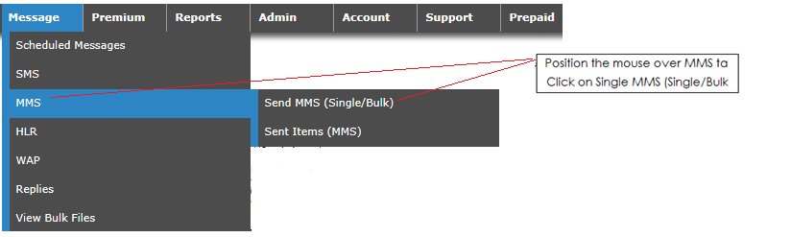

The following screen will appear

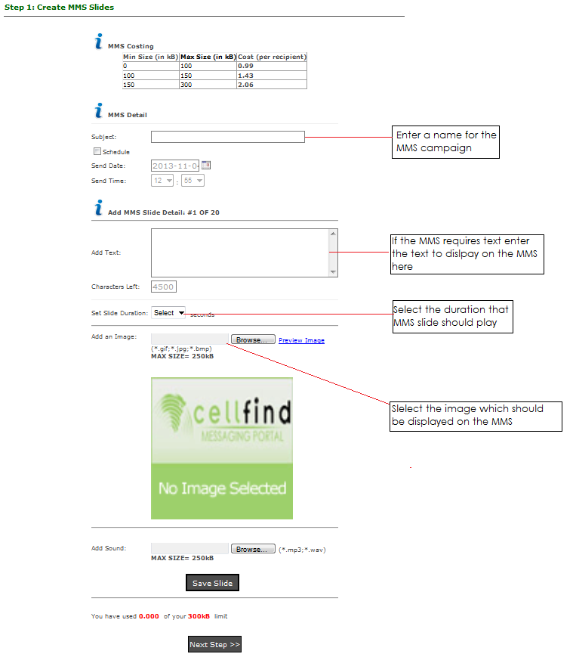
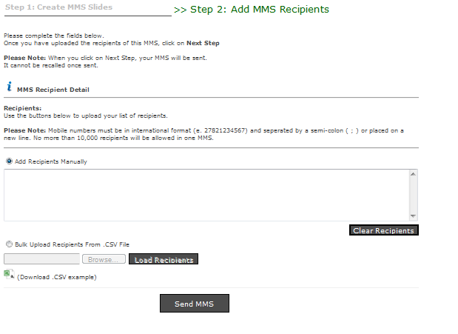

If a Bulk SMS is sent click on the Bulk upload recipients from. CSV file radio button

Example of the MMS bulk upload file
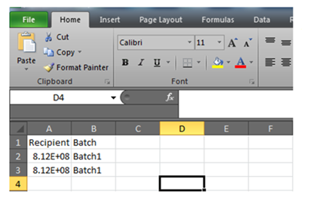

Save the file as a CSV. File as previously explained

Once the file has been uploaded click on Send MMS

To view sent MMS’s hover over the Message tab select MMS and then click on Sent Items (MMS)

The following screen will appear and you can then refine your search

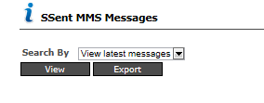

HLR
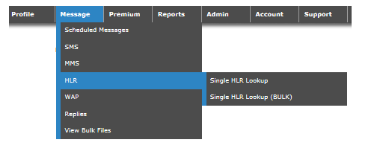

HLR lookup allows you to check the validity of a mobile number and provides extended details, including operator identification and roaming information. This is ideal for companies with large mobile number databases, as this identifies unused or inactive numbers which could reduce costs and save resources

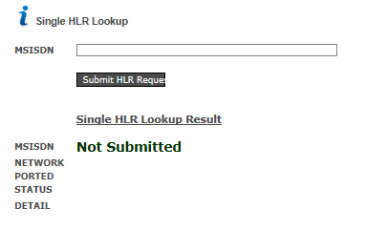

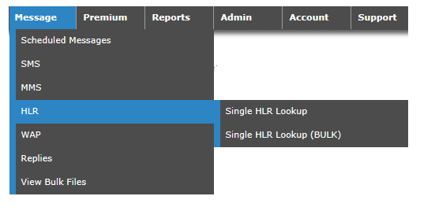
Submitting Bulk HLR requests

The same process is followed as for Bulk SMS submissions
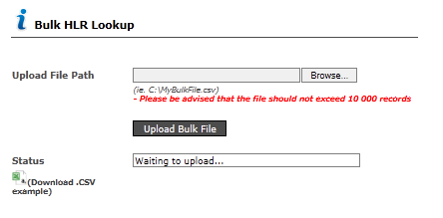

Example of a Bulk HLR .CSV file

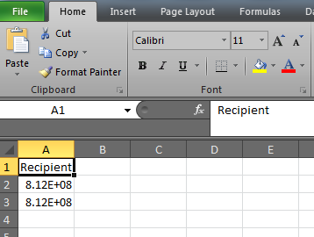

Sent Items

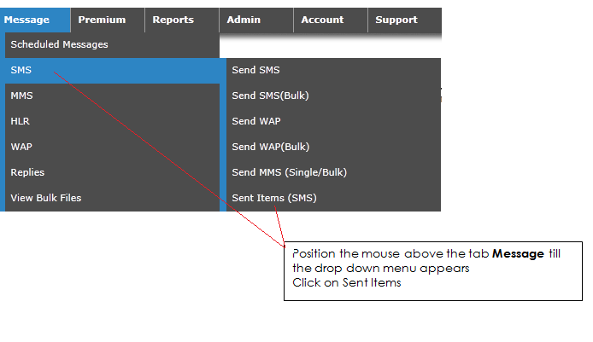
You can view a list of messages sent from your user account. These messages are displayed from the latest message sent to the oldest message sent.

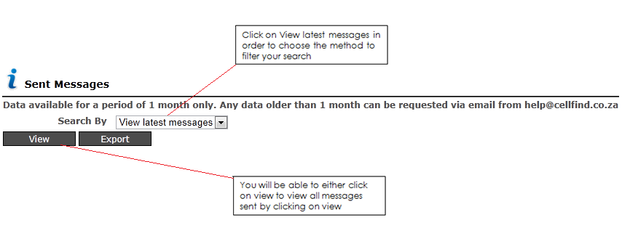
The following screen will appear

You can further refine your sent items search by the following criteria

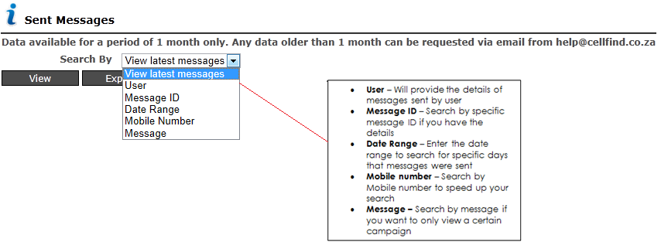

To export Sent items you need to click on the view button

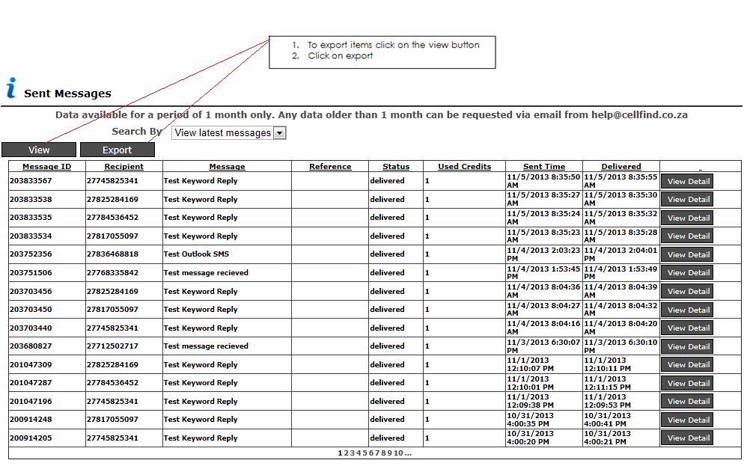

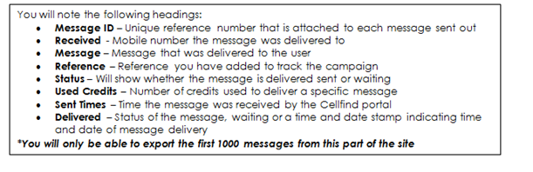

View of an exported CSV file
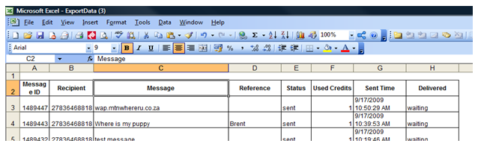

View Replies
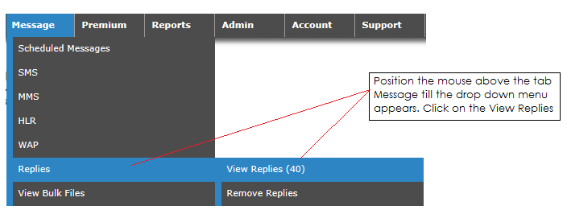
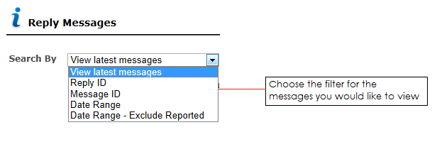
Here you will get a list of incoming “Reply” messages that were received for specific outgoing messages. These messages are displayed from the latest message to the oldest message received.
- Reply ID - A unique ID we attach to the message in order to track the message
- Destination No – Long Code number the reply comes back into the Cellfind system
- Originator – Mobile number that sent the reply into the Cellfind system
- Received time – Date and time that the message was received
- Remove – You can remove the message from this view
- View Detail – View a breakdown of when where and how the message was sent out

Remove Replies
Here you will get a list of incoming “Reply” messages that were received for specific outgoing messages. These messages are displayed from the latest message to the oldest message received. By selecting to remove the messages, will remove the messages from the list.
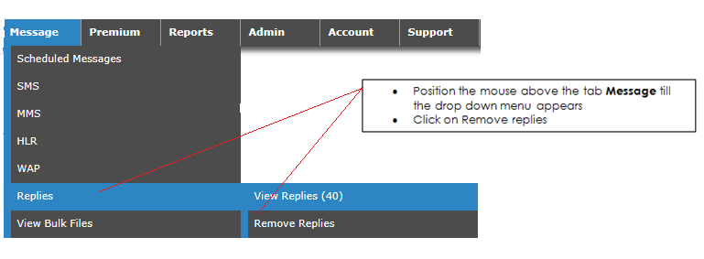

The following screen will appear

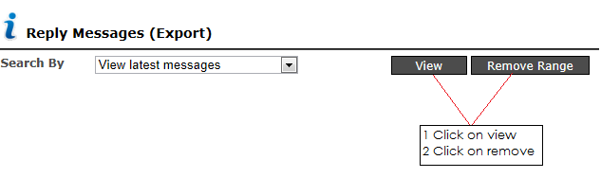

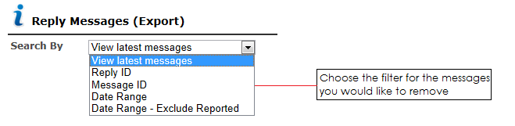

View Bulk Files

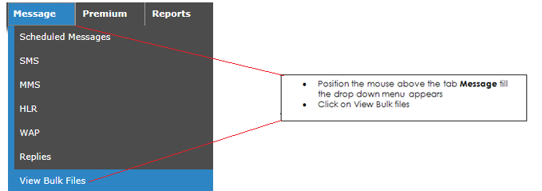

The following screen will appear

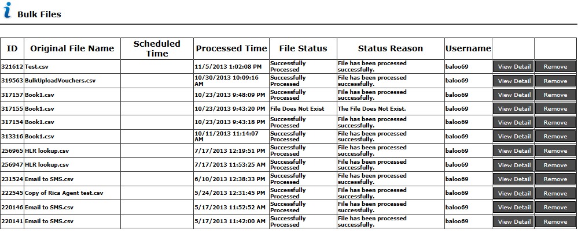

- ID - A unique ID we attach to the bulk message in order to track the bulk file
- Original File Name – Name of the file as saved on your PC and submitted to the Cellfind Portal
- Scheduled Time – Where a bulk files has been submitted to be delivered on a specific date
- Processed Time – Date and time that the message was received by the Cellfind Portal
- File Status – Whether it was successfully submitted to the Cellfind portal
- Status Reason – Description of where the file status is
- Username – Entity who submitted the file
- View Detail – Provides a user with further information on the file delivered

Premium Rated

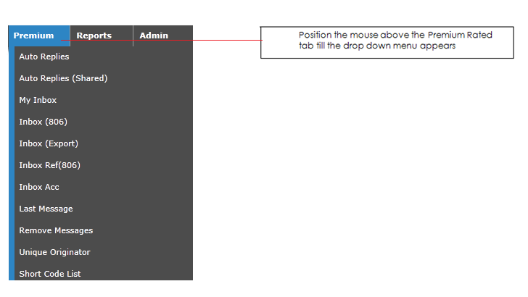
The Premium rated tab will only be available if you’re subscribed to this service

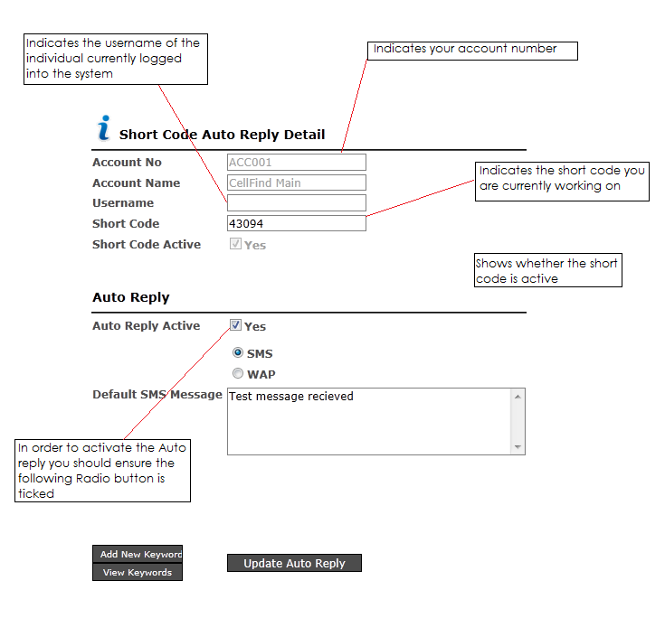

Auto Replies
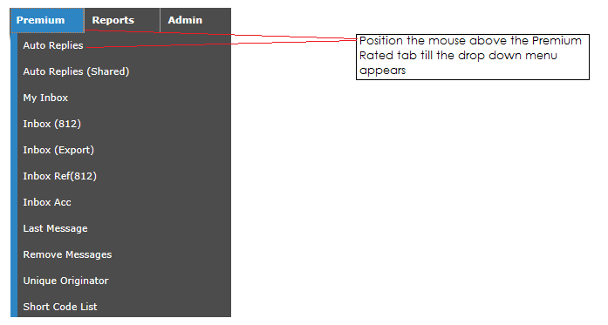
The Auto reply functionality on the Cellfind Portal provides you with the ability to automatically send a reply back to a customer if any messages are sent into your dedicated Premium Rated number.
If ticked the following screen will appear

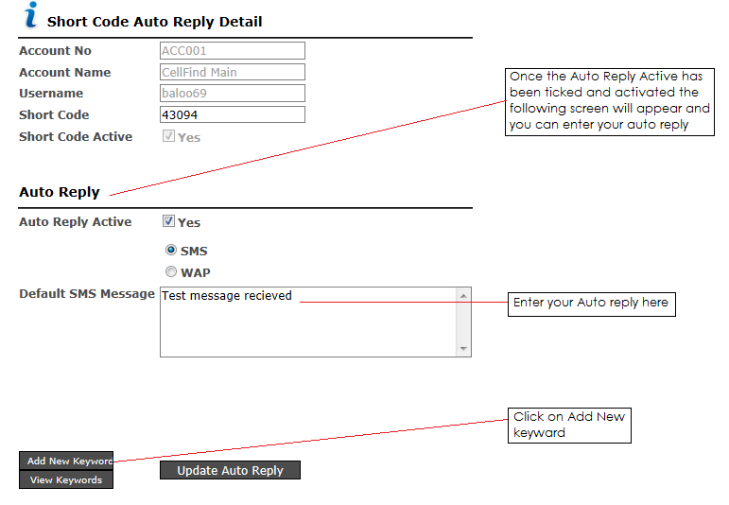

You will also be able to generate a specific auto reply if a specific keyword is used.

Once you click on Add New Keyword the following screen will appear

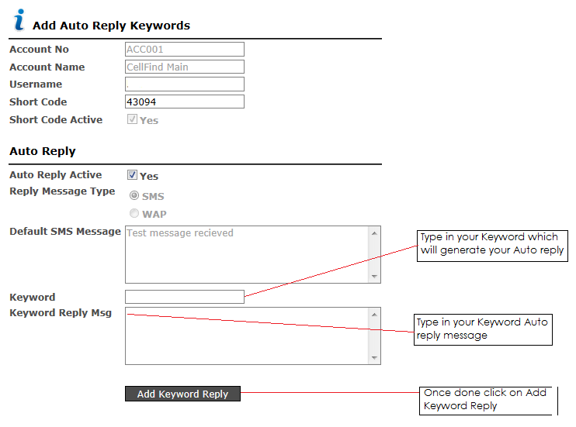

Auto Replies (Shared)

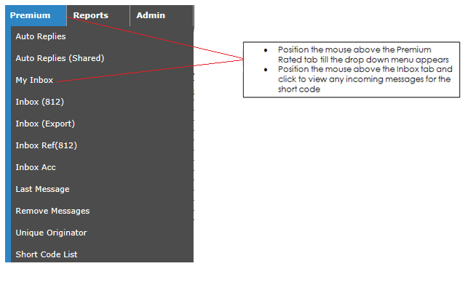
All Shared codes will be set up by account managers within Cellfind as dedicated keywords will be attached to your account.

Inbox
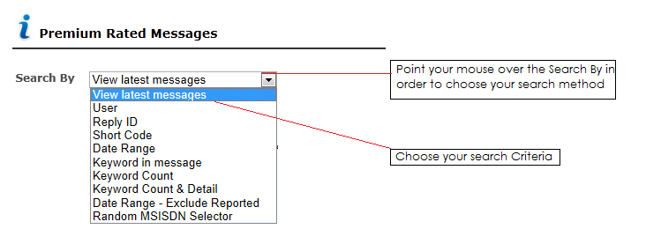
The following screen will appear

- View latest messages – Will provide you with all messages that have come into the system
- User – Will provide you with the messages that have come in by user
- Reply ID – This function will provide you with a specific message search criteria as every message will have a unique reply ID
- Short Code – If you have more than one short code you will be able to draw the replies per short code
- Date Range – Choose specific dates to narrow down your search criteria
- Keyword in message – Search for specific messages via a keyword
- Keyword count – Keyword count specified for a period either starting with a specific message or if a message contains a specific keyword
- Keyword count & Detail - Keyword count specified for a period either starting with a specific message or if a message contains a specific keyword
- Date Range – Exclude Reported – Exclude messages that have already been marked as viewed by Date range

Inbox (Export)

The following function can be used to export up to a 1000 messages
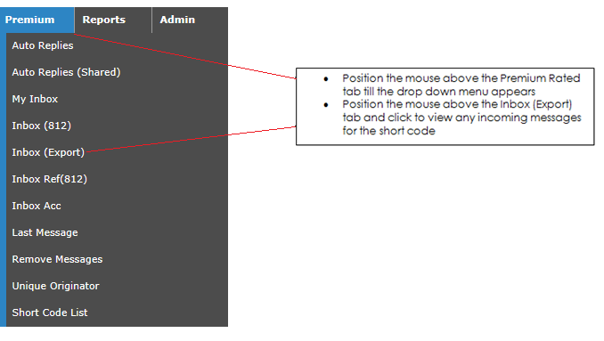

The following screen will appear
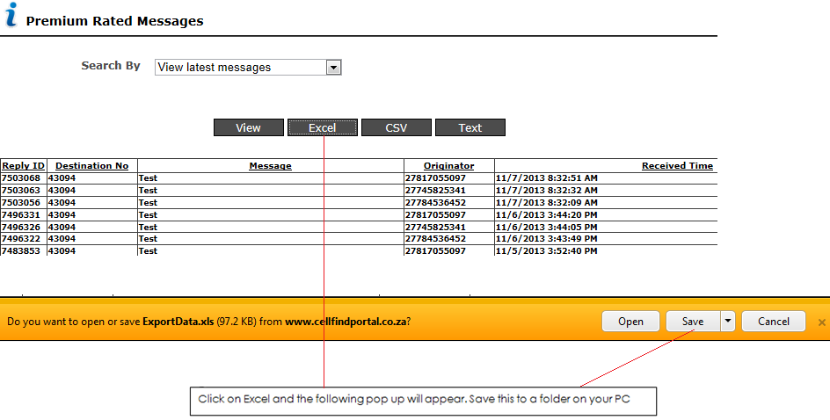

Inbox Ref
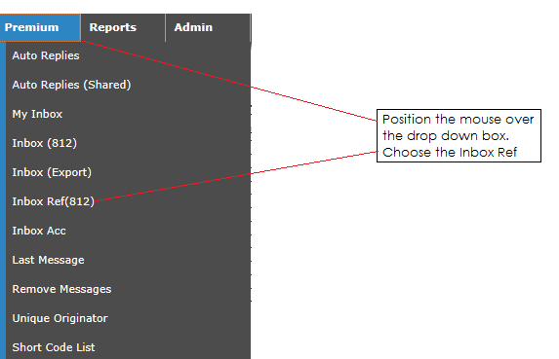

The following screen will appear
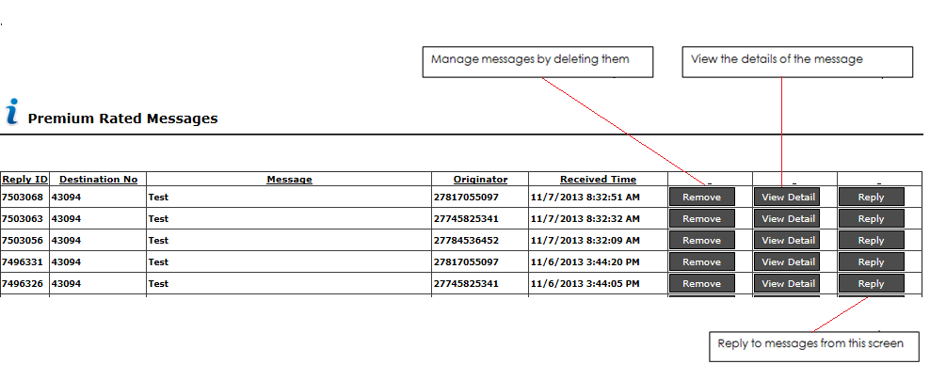
View details

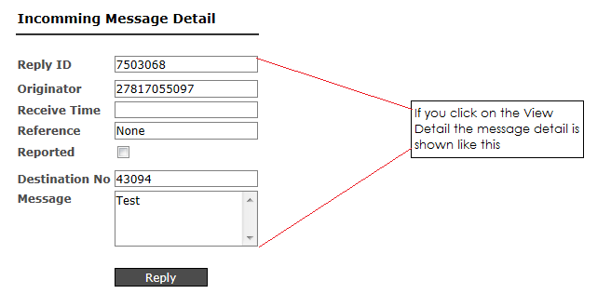

Last Message
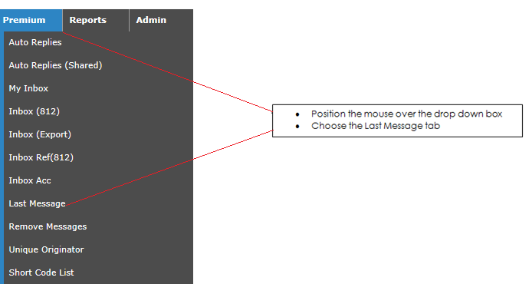
The following screen will appear providing you with a snap shot of the last message that has come into the system
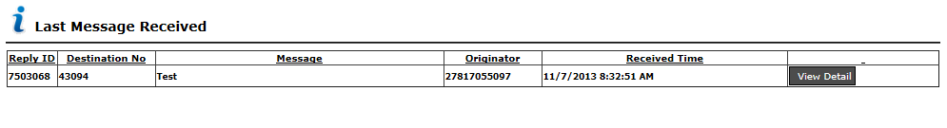

Remove Messages
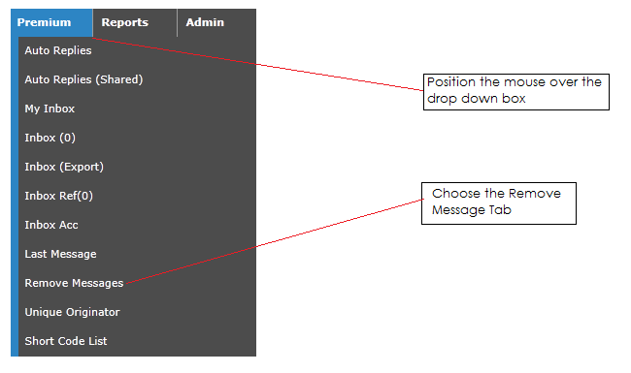

The following screen will appear
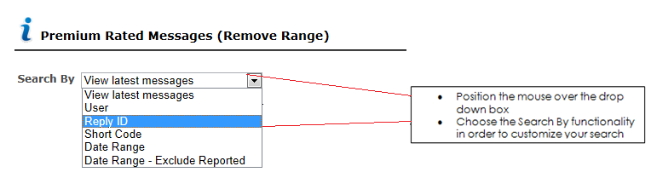
View latest message
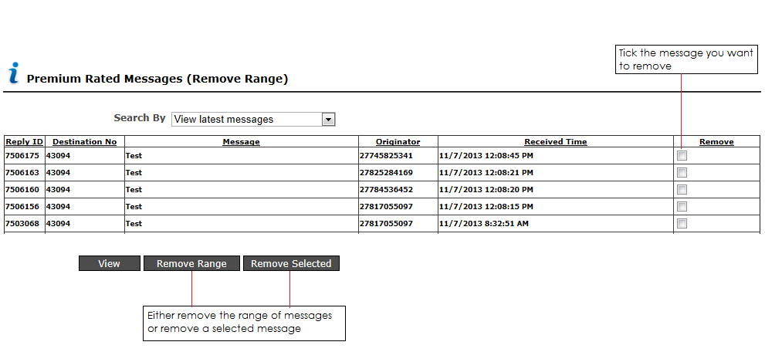

Unique Originator Count

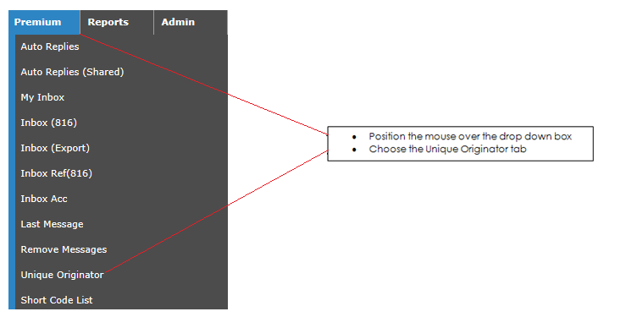

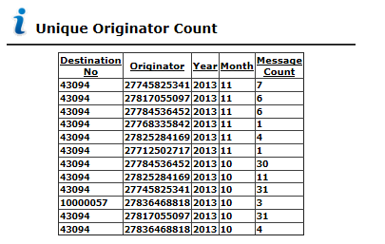

This will provide you with a snap shot of messages sent out and from which Mobile originating number.

Short Code List
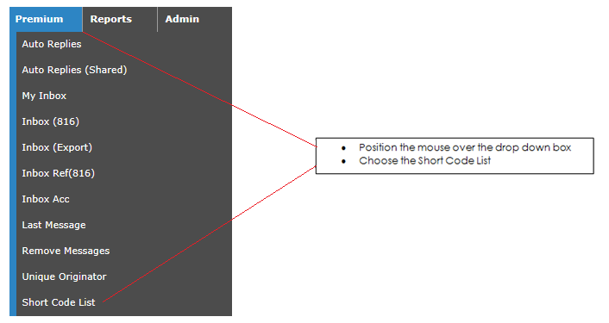

This will provide you with a snap shot of all the short codes under your
Account and with the names of users who have access to the short code
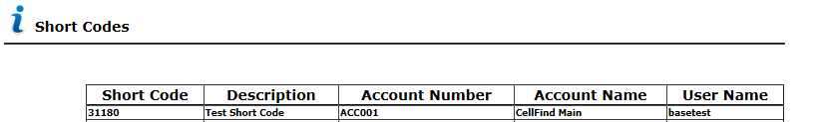

Reports

This screen will provide you with access to summarized as well as detailed reports

Standard Reports

Incoming msg count by date and short code
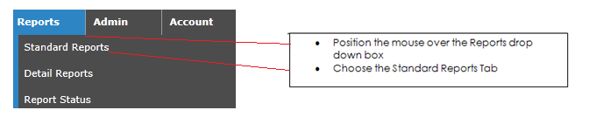
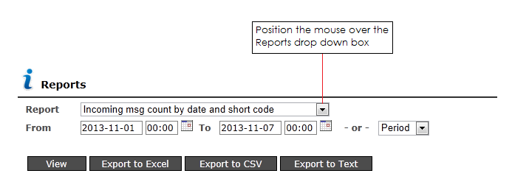
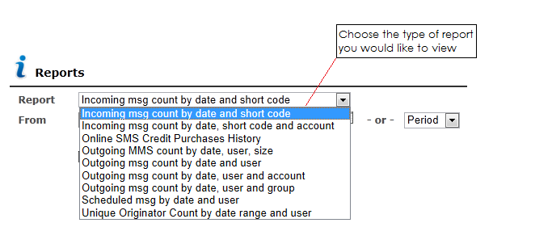
The following screen will appear

The following screen will appear

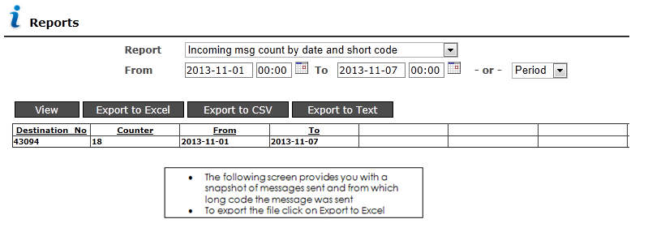

Incoming msg count by date and short code and account
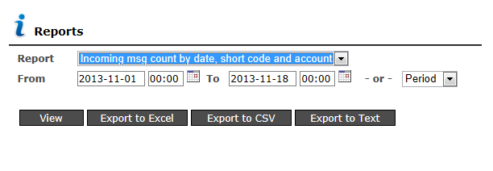
The following report will provide you with a summarized version of your whole account.

The below is an indication of the total number of incoming messages per inbox and short code.

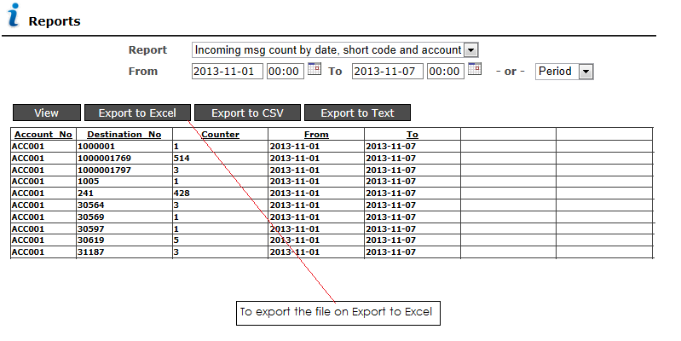

Outgoing msg count by date and user

The following report provides you with a summarized view of the messages sent out by date and by user
To export the file click on Export to Excel

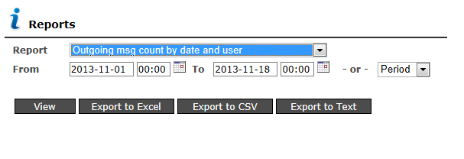

Outgoing msg count by date, user and account

The following report provides you with a summarized view of the messages sent out by date, user and account
To export the file click on Export to Excel

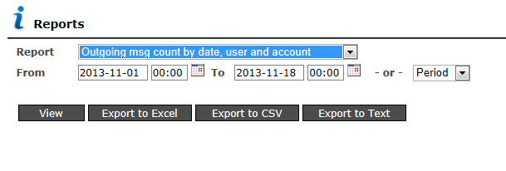

Scheduled msg by date and user

The following report provides you with a summary of any messages scheduled during the month with the total amount of messages sent out by the user.

Files can be exported by clicking on any one of the export buttons

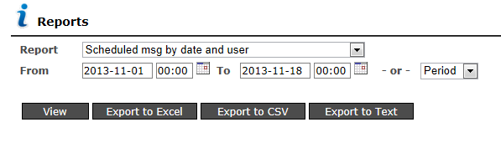

Detailed reports

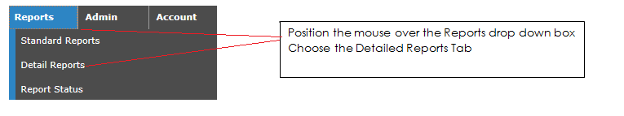

The following screen will appear:
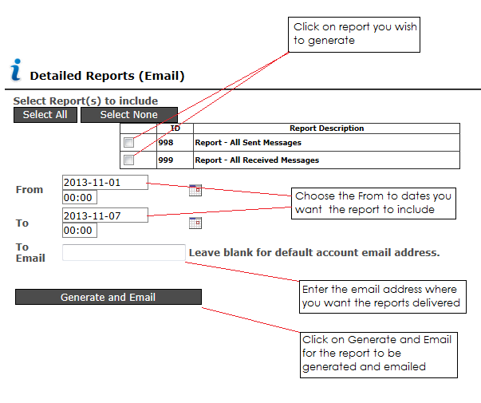
Once you have clicked on the generate email button a detailed report consisting of the message, user and sent time will be delivered to the e-mail address as captured on your profile page.

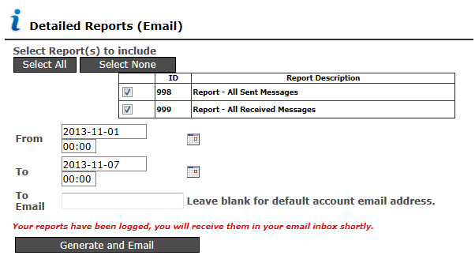
I.e. Report Received message file

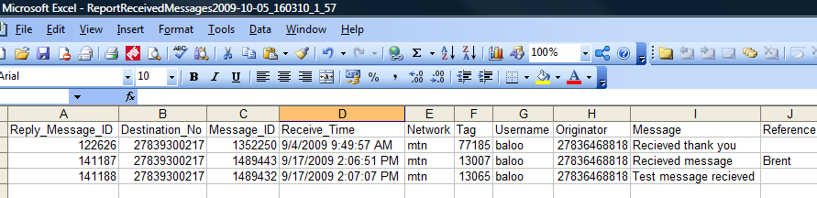

I.e. Report message sent file
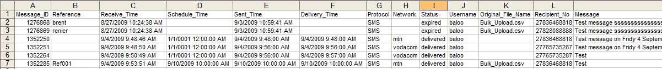

Log Out

This button will Log you out of the Website and end you web session on the Cellfind Portal

Contact details

For any sales queries contact us on the following email address:

info@cellfind.co.za

For any support assistance contact us via email on:

support@cellfind.co.za or smssupport@cellfind.co.za

Or telephonically on:

011 848 8201 or 011 848 8207

